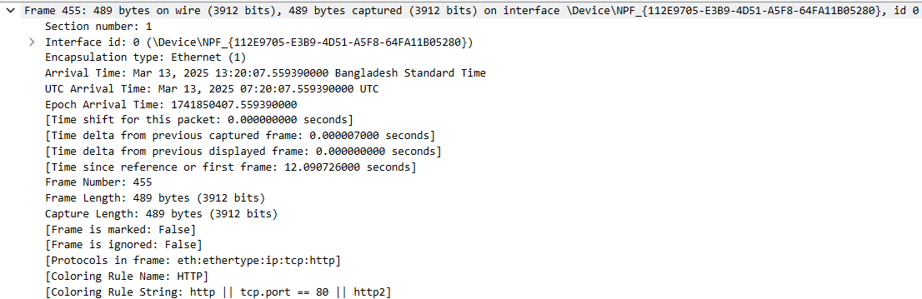

The physical layer deals with the transmission of raw bits over a physical medium (like electrical signals over wires, light signals in fiber optics, or radio waves in wireless communication). This layer isn't explicitly shown in the packet capture, but it underlies the transmission process that Ethernet (Layer 2) depends on. The transmission of bits (represented by Ethernet frames) is what occurs at this layer, although the actual physical medium isn’t captured in the image.

The image shows a packet capture at Layer 2 (Data Link Layer) and Layer 3 (Network Layer), with the details of the frame, including encapsulation type (Ethernet), frame length (489 bytes), and the time of arrival. This packet is using the HTTP protocol over TCP (port 80), which is confirmed by the protocol string "eth:ethertype:ip:tcp:http." The source and destination are using Ethernet, which handles the data link layer for proper communication within a local network. The IP layer handles the routing between different networks, and the TCP layer ensures that the data is transferred reliably, while the HTTP application-level protocol facilitates communication between the web browser (client) and web server. The timestamp and additional frame information provide insights into the timing and capture metadata.

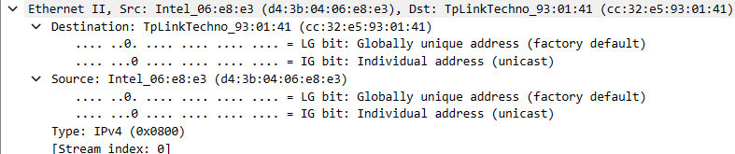

This image represents the Ethernet II frame, which is part of the Data Link Layer. The source and destination MAC addresses are displayed here. The Data Link Layer ensures data transfer across the physical link by managing the frame's structure, addressing (with MAC addresses), error detection (through CRC), and access to the transmission medium. In this frame, we can see that the source and destination are both identified using their MAC addresses, marking this as an operation of Layer 2.

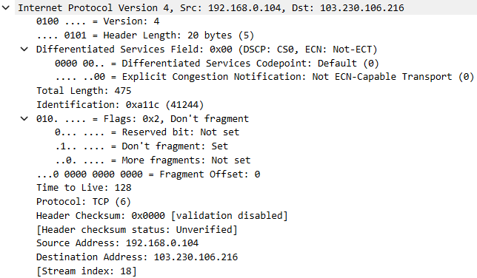

This image shows the IP packet, which is part of the Network Layer. The source IP address (192.168.0.104) and destination IP address (103.230.106.216) are visible in the packet header. The Network Layer is responsible for routing packets between different networks, and the IP header includes vital information like source and destination IP addresses, fragmentation details, and routing instructions. Here, the packet is being prepared for forwarding between devices on a network.

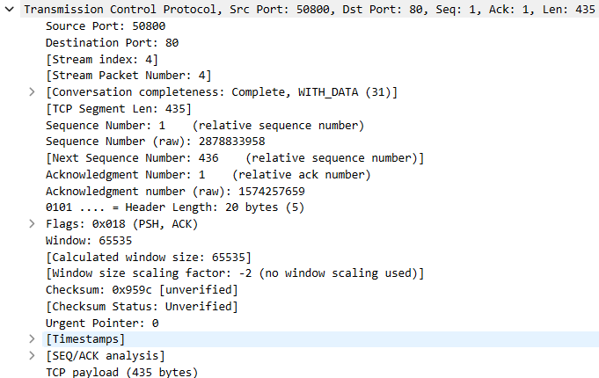

This image captures the TCP segment, part of the Transport Layer. It shows details like source and destination ports, sequence and acknowledgment numbers, flags, window size, and the TCP payload. The Transport Layer ensures reliable communication between hosts by managing connections, flow control, error correction, and packet sequencing. Here, we see a segment of data being prepared to be transmitted over TCP, ensuring the reliable delivery of data by confirming the correct sequence and handling any retransmissions if necessary.

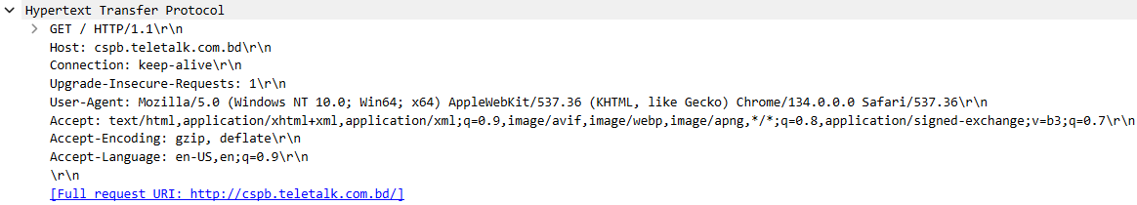

This image shows an HTTP request, which operates at the Application Layer. The HTTP method (GET), request URI (/), and other headers like Host, User-Agent, Accept, and Connection are visible. The Application Layer facilitates communication between user applications and network services, with HTTP being the protocol used for web-based communications. The headers define how the browser interacts with the web server to request resources such as HTML, images, or scripts, allowing the user to interact with the web.

——————————————————————————————————————

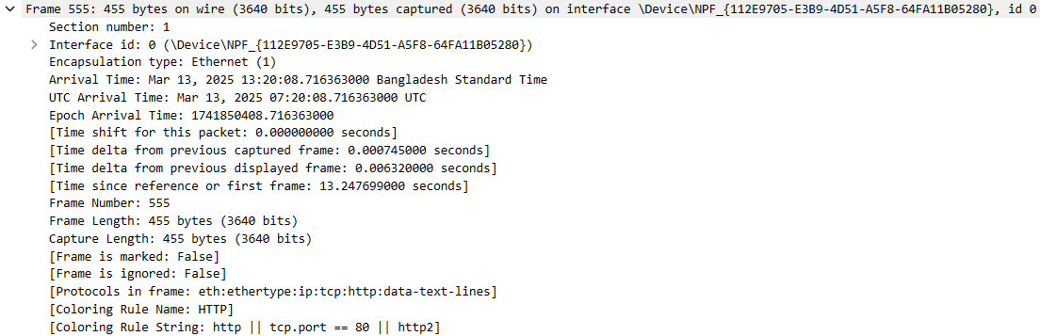

Not explicitly visible in the image, but the physical layer is responsible for the actual transmission of bits over the medium (like copper wires, fiber optics, or wireless signals). This layer is fundamental for transferring the raw data packets through physical channels, and its presence is implied by the transmission of frames and packets in the Data Link and Network layers.

The image displays a packet capture at Layer 2 (Data Link Layer) and Layer 3 (Network Layer). The frame details show that it is an Ethernet packet, with the encapsulation type being Ethernet. The frame is 455 bytes in length, and the captured length is also 455 bytes. The packet was captured on an interface at a specific timestamp in Bangladesh Standard Time. The protocols listed in the capture are Ethernet, IP, TCP, and HTTP, indicating that this packet is part of a communication over the internet. The TCP port 80 is used, which is standard for HTTP traffic, and the packet includes HTTP data-text-lines as indicated by the "Coloring Rule String." This packet is most likely part of an HTTP request or response, which is processed at the Application Layer (Layer 7). The captured frame gives insight into the encapsulation of HTTP data over the network and its transmission through the different OSI layers.

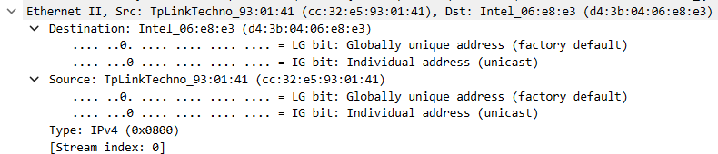

This image shows the Ethernet II frame. The Data Link Layer handles the MAC addressing (source and destination), ensuring that data is transferred reliably across the local network. Here, the source MAC address (TpLinkTechno_93:01:41) and destination MAC address (Intel_06:e8:e3) are shown, which helps ensure that the data reaches the correct physical device.
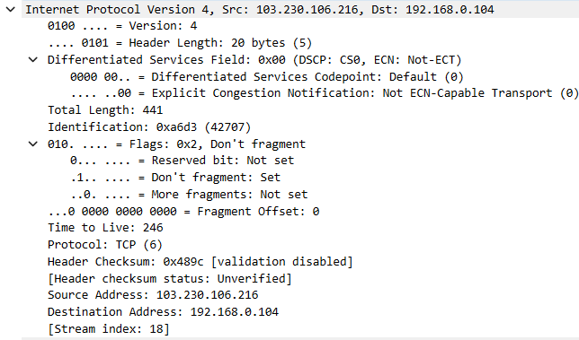

This image represents an IP packet that is part of the Network Layer. The source IP (103.230.106.216) and destination IP (192.168.0.104) addresses are shown. The Network Layer is responsible for routing data across networks, and this packet includes information for routing and fragmentation. The IP header encapsulates the data and ensures it is directed to the correct destination device on the network.

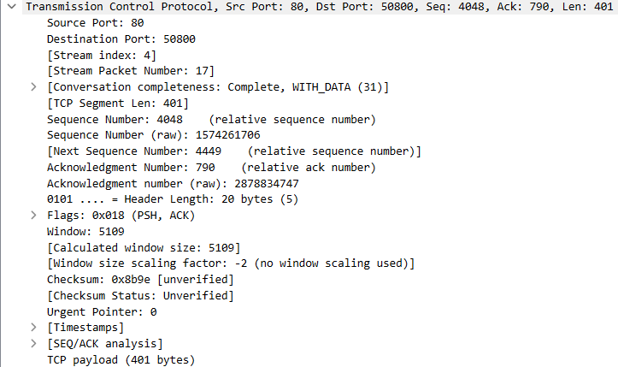

This image shows the TCP segment, which belongs to the Transport Layer. The TCP segment includes information such as the source and destination ports, sequence numbers, acknowledgment numbers, and flags (e.g., PSH, ACK). These elements ensure reliable, ordered delivery of data between applications running on different hosts. The TCP segment is essential for managing the communication between devices.
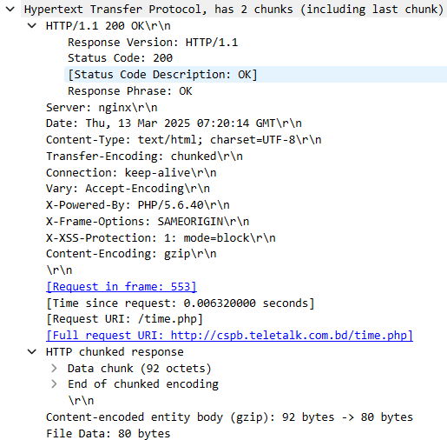
This image shows an HTTP response packet, which operates at the Application Layer. The HTTP response includes a status code (200 OK), headers (like Content-Type, Server, Transfer-Encoding), and the response body. The Application Layer is where end-user communication protocols like HTTP, FTP, and DNS operate. HTTP handles web communication between clients (like browsers) and servers.

